Documentation for the Application using Bootstrap and PHP

* Create a blank HTML Document with the sections Head and Body like:

* Change the title to Contact Us
* Use Bootstrap CSS link in the head section



*“ <link href="https://cdn.jsdelivr.net/npm/bootstrap@5.1.3/dist/css/bootstrap.min.css" rel="stylesheet" integrity="sha384-1BmE4kWBq78iYhFldvKuhfTAU6auU8tT94WrHftjDbrCEXSU1oBoqyl2QvZ6jIW3" crossorigin="anonymous"> “*

* Just before the closing body tag, include the Bootstrap Bundle with Popper, by using

*“<script src="https://cdn.jsdelivr.net/npm/bootstrap@5.1.3/dist/js/bootstrap.bundle.min.js" integrity="sha384-ka7Sk0Gln4gmtz2MlQnikT1wXgYsOg+OMhuP+IlRH9sENBO0LRn5q+8nbTov4+1p" crossorigin="anonymous"></script>”*

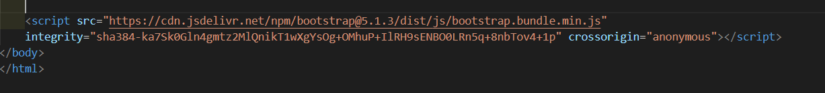

* This bundle is required by the Bootstrap to function properly. Many components of Bootstrap use javascript to function.
* Create a navigation bar.
* Create a nav tag with classes “navbar navbar-expand-lg navbar-dark bg-dark”. Refer bootstrap documentation for these classes
* Create a div tag with class “container-fluid”. This is used for a full width, spanning the entire width of the page of the device.
* Then create a “a” tag using
* <a class="navbar-brand" href="#">Contact Us </a>

Class navbar-brand is used to show the project name or company name

* Then to make it a button, create a button tag as follows:



Refer bootstrap documentation for classes and attributes. Navbar toggler is used to collapse the navigation bar in case the website is being viewed on a smaller device.

* Create a div tag and start creating the options in the navigation bar using ul tag like below:

For Home link, href attribute should refer to itself.

I have created some options in the navigation bar like link to another application, some drop down menu

* Create a form tag as below to create a search area along with a search button.

Class d-flex is used to create a flexible container.

* Create a form as below to get the details of the user

This will create a form with name, email and concern as fields.

**PHP section:**

In the php section first I’m disabling the error display as user may not want to see a technical error message.

ini_set('display_errors', '0');

Rest of the php code will be under and if condition which checks if the server request is post.

if ($_SERVER['REQUEST_METHOD'] == 'POST'){

Get the inputs from the form and store them in a variable.

Settings the variables with the Database details:

Connecting to the database and checking if the connection is successful otherwise close the connection by displaying proper message.

I used mysqli_report to handle the warnings and errors conveniently.

Create an insert query to insert the values in the database.

If the insert operation is successful, a success message will be displayed, otherwise an error message is displayed.

Application:

<https://prabhakg.myweb.cs.uwindsor.ca/second/>

References

* <https://getbootstrap.com/docs>